YM Gathering May 24, 2020 Personal Reflection:
We are so grateful the Fr. Sarfraz joined us and shared his experiences and wisdom with us. Please continue to pray for him!

Read through of these Scripture passages and reflect on the questions. Journal about it, pray about, and/or discuss it w/ others:

Matthew 28:16-20
In this passage, Jesus is speaking his very last word to the disciples before he ascends into Heaven. It is known as the “Great Commission”
- What words of challenge does Jesus give us in his statement? What does he want us to do?
- What words of encouragement does he give us in his statement?
- How does that challenge and encouragement apply to YOUR LIFE? Remember, if you are a follower and disciple of Jesus, he speaks directly to YOU when he speaks to his disciples!

Acts 1:4-11
This story from Acts gives more details about what happened when Jesus ascended into Heaven.
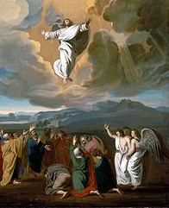
    - Take a few minutes and imagine you were there, standing on the mountain, watching Jesus float up into the sky!
- Picture your friend Jesus as he gets smaller and smaller as he rises higher and higher… what might you feel as you witness this?
- Picture the angels… what might they have sounded like?
- Imagine “what’s next”… what will the new normal look like after Jesus is gone? Keep in mind that he promises to send the Holy Spirit to empower the disciples with wisdom, understanding, knowledge, right judgement, courage, wonder and awe and piety!

Next week we celebrate Pentecost!!! GET EXCITED!!! Bishop Pates is celebrating a special live-streamed Mass specifically for Confirmation candidates, their sponsors, and families on Pentecost—Sunday, May 31st at 2 pm. Please tune in!

Prayer to the Holy Spirit:

- Breathe into me, Holy Spirit, that my thoughts may all be holy.
- Move in me, Holy Spirit, that my work, too, may be holy.
- Attract my heart, Holy Spirit, that I may love only what is holy.
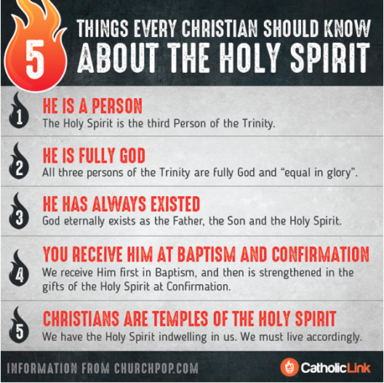
- Strengthen me, Holy Spirit, that I may defend all that is holy.
- Protect me, Holy Spirit, that I may always be holy.

Add in your prayers to the Holy Spirit…
- Holy Spirit, I praise you because you are…
- Holy Spirit, thank you so much for…
- Holy Spirit, I’m sorry for…
- Holy Spirit, please bless…
- Holy Spirit, help me with…
- Holy Spirit, I open my heart to you and offer to you…

________________________________________________________________________________________________________

Join us for YM Live-Stream on Pentecost Sunday, May 31st at 7 pm!

Second reading for Pentecost: 1 Corinthians 12:3-7, 12-13
The Living Bible Translation: 4 Now God gives us many kinds of special abilities, but it is the same Holy Spirit who is the source of them all. 5 There are different kinds of service to God, but it is the same Lord we are serving. 6 There are many ways in which God works in our lives, but it is the same God who does the work in and through all of us who are his. 7 The Holy Spirit displays God’s power through each of us as a means of helping the entire church.
12 Our bodies have many parts, but the many parts make up only one body when they are all put together. So it is with the “body” of Christ. 13 Each of us is a part of the one body of Christ. The Holy Spirit fits us all together into one body. We have been baptized into Christ’s body by the one Spirit, and have all been given that same Holy Spirit.

ACTION ITEM FOR YOU: How do you fit into the “body of Christ?” If you could see yourself as one body part, what would you be? Think about what you love to do and what you are good at! Please send us a 10 second clip sharing how you are a part of body of Christ!

